Documentation of

RPA Log Dashboard

Team

Savvy Insights

Swetha Srivarna Selv[aganesan(swethasrivarnas@gmail.com](mailto:swethasrivarnas@gmail.com)**)**

Suhadev Venkatesh( [Suhadevvenkatesh@gmail.com)](mailto:Suhadevvenkatesh@gmail.com)

**Contents**

**1. Problem Statements** .................................................................................................... 3

**2. Key Objective** ............................................................................................................... 3

**3. Functional Requirement** .............................................................................................. 3

**4. Software Requirements** ............................................................................................... 3

5. **Approach** ...................................................................................................................... 4

5.1 Design Thinking Process Approach ........................................................................ 4

5.2 Application Requirements ....................................................................................... 5

5.3 Cost involved for implementation ............................................................................ 6

**6. Use Cases**..................................................................................................................... 6

6.1 Home Page............................................................................................................. 7

6.2 Common across Dashboards.................................................................................. 8

6.3 Log Summary ......................................................................................................... 8

6.4 Log Analytics ........................................................................................................ 11

6.5 Failure Analytics ................................................................................................... 13

**7. Scope Statement**........................................................................................................ 15

7.1 Email Alerts........................................................................................................... 15

7.2 Failure Prevention................................................................................................. 15

7.3 Failure mode Prediction ........................................................................................ 15

**8. Assumptions, Risks & Limitations** ........................................................................... 15

8.1 Assumptions ......................................................................................................... 15

8.2 Risks..................................................................................................................... 15

8.3 Limitations ............................................................................................................ 15

**1. Problem Statements**

As given in the Power Up Automation Hackathon:

Ready-made dashboards which can be deployed by users in their environments. Will use the UiPath robot’s logs as a data source. Can be made in Kibana or any other reporting/BI platform. It would be great if a mockup is submitted along with the idea, or at least comprehensive descriptions of all the data points. File type: .json files

**2. Key Objective**

To provide descriptive analysis from the UiPath robot’s logs that would help users to take business decisions and bring value. Also to forecast the trends based on analytics model that would help in rendering both predictive and preventive analytics.

Value would include:

• Load planning based on the Bot Availability

• Delivery Planning based on the Bot Performance and Runtime

• Schedule Planning (On-time and Hassle-free execution and Transactions)

• Failure prediction and prevention

• 100% Utilization of the Bots

• Cost savings

• Return on Investments

**3. Functional Requirement**

• Data source from UiPath robot’s details

• Data source from UiPath robot’s logs

• Data Storage and Processing

• Connecting Data source with the BI tool

• Identification of all Use cases and Metrics

• Dashboard development using Tableau Public/any BI tool

• Comprehensive descriptions of all the use cases

**4. Software Requirements**

|  |  |  |  |
| --- | --- | --- | --- |
| S.No | Software | Purpose | Download Link |
| 1. | Python  Anaconda3 | Convert .json to csv | <https://www.continuum.io/downloads> |
| 2. | SQL Server 2012  Express edition | Data Storage  and Processing | [https://www.microsoft.com/en-](https://www.microsoft.com/en-gb/download/details.aspx?id=29062)  [gb/download/details.aspx?id=29062](https://www.microsoft.com/en-gb/download/details.aspx?id=29062) |
| 3. | Tableau | Data  Visualization | [https://www.tableau.com/products/des](https://www.tableau.com/products/desktop)  [ktop](https://www.tableau.com/products/desktop) |

5. **Approach**

5.1 Design Thinking Process Approach

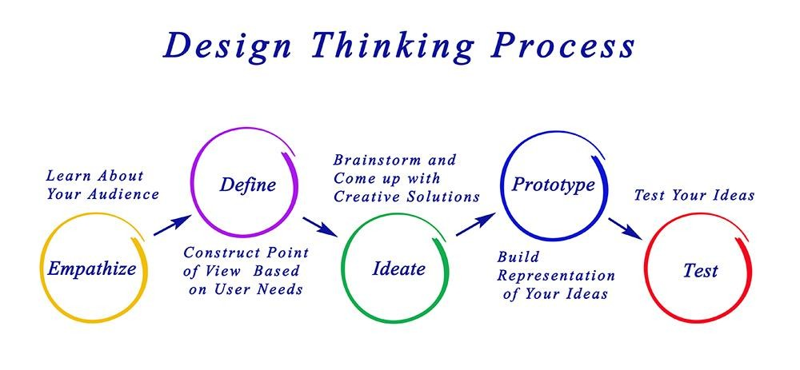

Timeline August 10th to 28th 2018

***Empathize***

***Define***

***Ideate***

***Prototype***

***Test***

•Day 1

•Day 2-3

•Day 4-7

•Day 8-16

•Day 17-18

Empathize phase:

We began with pen and paper, noting down all the requirements that have to be considered for the building of the dashboards thinking as an end user.

Define phase:

Our initial thoughts involved Data Source, How the data would be stored, How the data to be processed and How the output of processed data would be visualized.

Ideate phase:

We came up with multiple ideas involving various technologies and techniques to be involved for developing an end product – Dashboard

Prototype phase:

We started developing dashboard using Tableau and iterated according to the ideation and implementing UI/UX on the way.

Test phase:

We tested the dashboard with various people (both technical and non-technical) in order to bring out the essence of the dashboard.

5.2 Application Requirements

• UiPath Bot

Logs

Direct

Connection • Tableau

• SQL Server

Database

Data Source

BI Dashboard

Data pipeline would include

• Python code to parse the log files

• Parsed data to be stored in SQL Server

• SQL Server data connection to Tableau

**Deployment Diagram – Data pipeline**

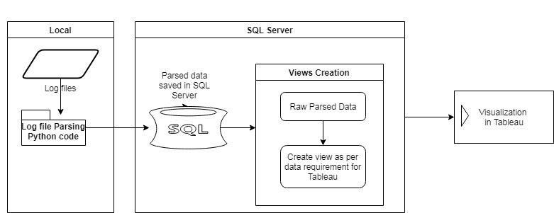

©Team Savvy Insights Page 5 of 15 V1.0

5.3 Cost involved for implementation

Basic implementation

**S.No Software Product Type Cost Per Annum for Basic**

**Implementation**

|  |  |  |  |
| --- | --- | --- | --- |
| 1 | SQL Server | Standard - Per core | USD 3,717.00 |
| 2 | Python | Open Source | USD 0.00 |
| 3 | Tableau | Tableau Creator | USD 840.00 |
|  |  | **Total** | **USD 4,557.00** |

Enterprise Implementation

**S.No Software Product Type Cost Per Annum for**

**Enterprise Implementation**

|  |  |  |  |
| --- | --- | --- | --- |
| 1 | SQL Server | Enterprise | USD 14,256.00 |
| 2 | Python | Open Source | USD 0.00 |
| 3 | Tableau | Enterprise | USD 152,400.00 |
|  |  | **Total** | **USD 166,656.00** |

**6. Use Cases**

We developed the dashboard using a dummy dataset(Superstore data of tableau edited as required for dashboard development) . Once we have the original dataset, the dashboard could be implemented based on the description provided for each dashboard use case.

Dashboard link - [https://public.tableau.com/profile/swetha.srivarna.s#!/vizhome/SavvyInsights-](https://public.tableau.com/profile/swetha.srivarna.s#!/vizhome/SavvyInsights-PowerUpAUTOMATION/HomePage) [PowerUpAUTOMATION/HomePage](https://public.tableau.com/profile/swetha.srivarna.s#!/vizhome/SavvyInsights-PowerUpAUTOMATION/HomePage)

*(It is published on* [*Tableau public,*](https://public.tableau.com/en-us/s/) *thus anyone could access it. For enterprise level,*

*it would be published in* [*Tableau Server a*](https://www.tableau.com/products/server)*nd users can be monitored.)*

©Team Savvy Insights Page 6 of 15 V1.0

6.1 Home Page

This Dashboard could be integrated to the UiPath Website or customer specific sites. When the user clicks on the “UiPath RPA Log Dashboard”, the user would land in the Home Page.

From here the user could be directed to

• The Log Summary dashboard which would provide the descriptive analysis of the data.

• The Failure Analytics which would provide insights on the failure and details about the failed Bots, thereby forecasting the failure.

• The Log Analytics which would provide insights to plan and implement business decisions.

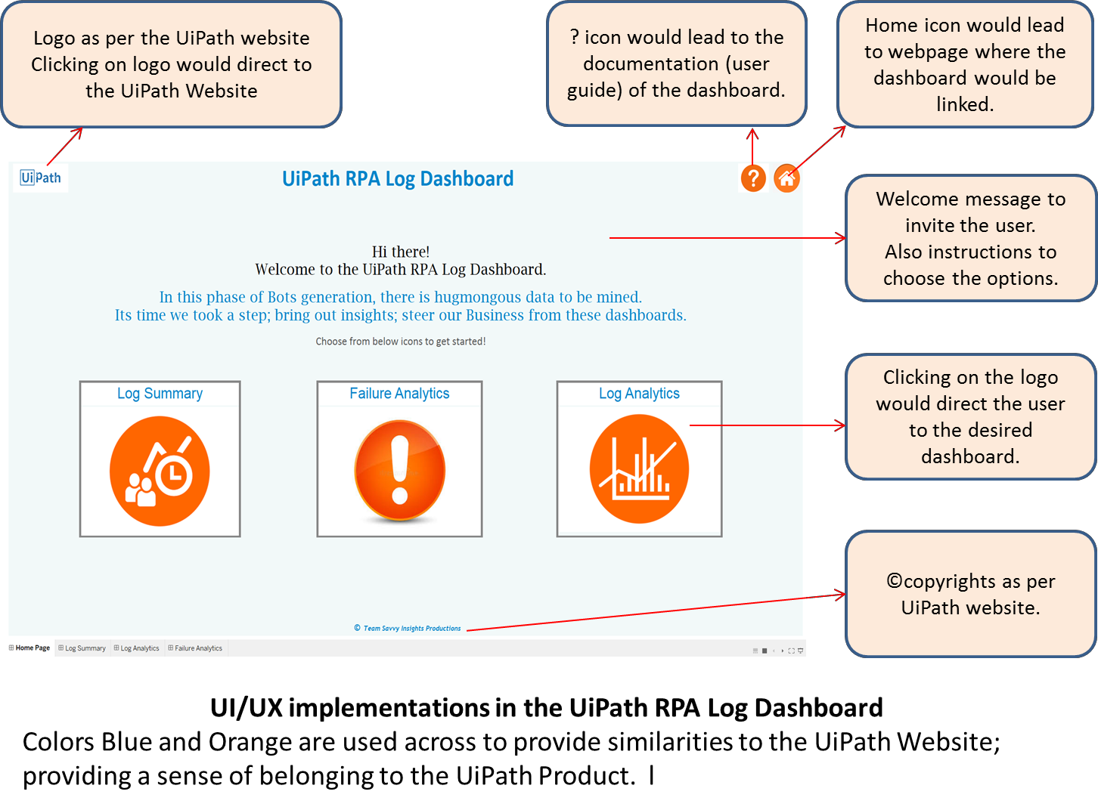

6.2 Common across Dashboards

|  |  |  |
| --- | --- | --- |
| **Visualization** | **Description** | **Logic Implementation** |
| **Common Across Dashboards** | | |
|  | Filters across all the  dashboards.  ***Allow users to drilldown the values based on Bot Name, Process Name and Date Period.*** | Metrics-  1. Bot Name  2. Process Name  3. Date |
|  | How to view the  dashboard | Clicking on the icon  would redirect to the documentation  prepared on UiPath RPA Log dashboard. |
|  | Home | Would direct to the  home page where all the different dashboard  icons are placed. |

6.3 Log Summary

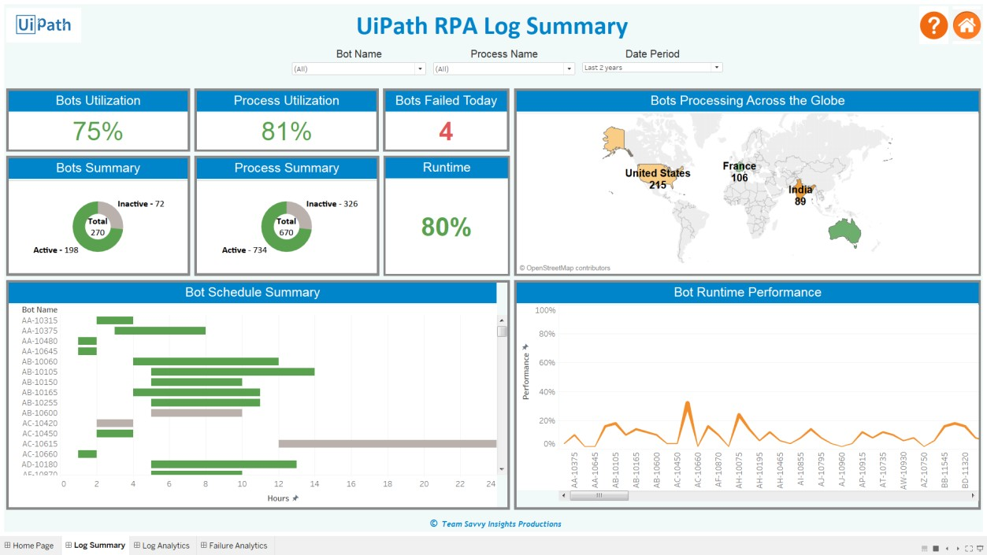

|  |  |  |
| --- | --- | --- |
| **Log Summary** | | |
|  | To understand whether all  the Bots are completely utilized  ***Allows us to provide the cost savings and return on Investment for all the***  ***Bots.*** | Bot Utilisation:  [(No of hours Bot ran per day / 24) * 100]  (In %) |
|  | Bots Count Summary  (Total, Active, Inactive) The below provides the overall summary of the Bots on a given day.  ***Allows the Bot Owner to utilize all the available Bots for other process planning.*** | Metrics-  1. Count Distinct of Bot  ID/Bot Name  2. Status –  Active/Inactive |
|  | To understand whether all  the processes are successfully completed  ***Allows the Bot owner to plan the Load accordingly.*** | Process Utilization:  [(No of Items  Successfully processed)  – (No of Exceptions) /  (Total no of Items)] *  100 (In %) |
|  | This gives the high level  view of the complete process history.  ***Allows the Bot Owner to understand the total number of available processes in the business and lets them to plan their delivery and load balancing accordingly.*** | Metrics-  1. Count Distinct of Process ID/ Process Name  2. Status –  Active/Inactive |
|  | To provide the number of  bots failing on a given day.  ***Allows the users to understand the failure of any Bots on a given day.*** | Metrics-  1. Count of Bot Errors  2. Filter date as Today |

©Team Savvy Insights Page 9 of 15 V1.0

|  |  |  |
| --- | --- | --- |
|  | This gives the performance  of the Bot per day. The Scope of this chart is to utilize the bots to their utmost ability.  ***Based on the historic data, the Bot Owner could***  ***target for certain performance value.*** | The logic would be  calculations based on the number of hours a Bot is running per day to the number of process successfully completed by the Bot. |
|  | Global Distribution allows  the user to have a consolidated view of all  the Bots and their location.  ***Allows users to take a consolidated look on the bots they own.*** | Metrics-  1. Count Distinct of Bot  ID/Bot Name  2. Location of the Bot |
|  | The Schedule summary  gives the total allocation of the Bot for a given day  over 24 hours. Based on this Gantt chart, the Bot Owner could assign the schedule for any upcoming process.  ***Provides recommendations in the future based on the analytics model.*** | Metrics-  1. Bot Name  2. Status –  Active/Inactive  3. Hours allocated per day for processes  (0-24 hours) |
|  | This gives the runtime  performance of each Bot per day. The Scope of this chart is to utilize the bots to their utmost ability.  ***Based on the historic data, the Bot Owner could***  ***target for certain performance value.*** | Metrics –  1. Runtime  Performance  2. Bot Name  3. Filter date as today |

©Team Savvy Insights Page 10 of 15 V1.0

6.4 Log Analytics

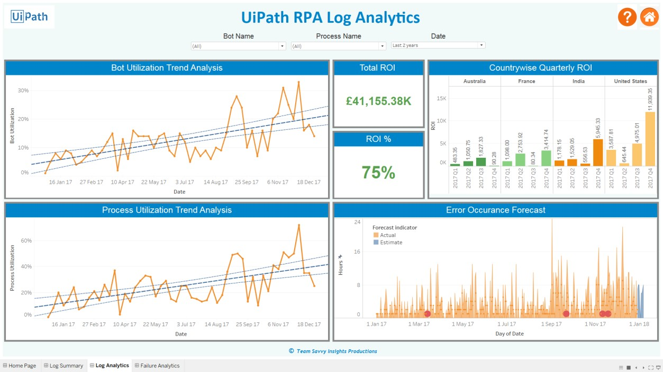

|  |  |  |
| --- | --- | --- |
| **Log Analytics** | | |
|  | To understand whether all  the Bots are completely utilized  ***The Blue trend lines provide the distribution (High, Median and Low lines) of the Bot utilization across a given time period.*** | Bot Utilization:  [(No of hours Bot ran per day / 24) * 100]  (In %)  Trend calculation in  Tableau  Metrics –  1. Bot Utilization  2. Time Period |
|  | To understand whether all  the processes are successfully completed  ***The Blue trend lines provide the distribution (High, Median and Low lines) of the Process utilization across a given time period.*** | Process Utilization:  [(No of Items  Successfully processed)  – (No of Exceptions) / (Total no of Items)] *  100 (In %)Trend calculation in Tableau  Metrics –  1. Process Utilization  2. Time Period |

©Team Savvy Insights Page 11 of 15 V1.0

|  |  |  |
| --- | --- | --- |
|  | Business users can  customise their ROI calculations based on their needs.  ***Providing the ROI allows users to have a check on their investments on the Bots.*** | ROI calculations involves  several parameters of investments and returns like  1. License cost  2. Development cost  3. Maintenance cost  4. Hours saved  5. Cost/hour |
|  | Calculating the total  percent of ROI achieved.  ***Allows users to know the level of ROI achieved as per the revenue goal set got the financial year.*** | Metrics-  1. ROI  2. Revenue Goal Value |
|  | Distribution of the ROI  across the different geographical locations.  ***Allows users to understand the ROI concentration and take business decisions accordingly.*** | Metrics-  1. Locations  2. ROI  3. Time Period - Quarterly |
|  | To understand how the  errors have occurred in the past, thereby forecasting the error occurrence for  the future.  ***The Blue estimate provides a look into how the errors would occur in the future (current data till 2017, the chart forecasts for 2018).*** | Metrics-  1. Count of Bot Errors  2. Time period  Forecast calculation in  Tableau |

©Team Savvy Insights Page 12 of 15 V1.0

6.5 Failure Analytics

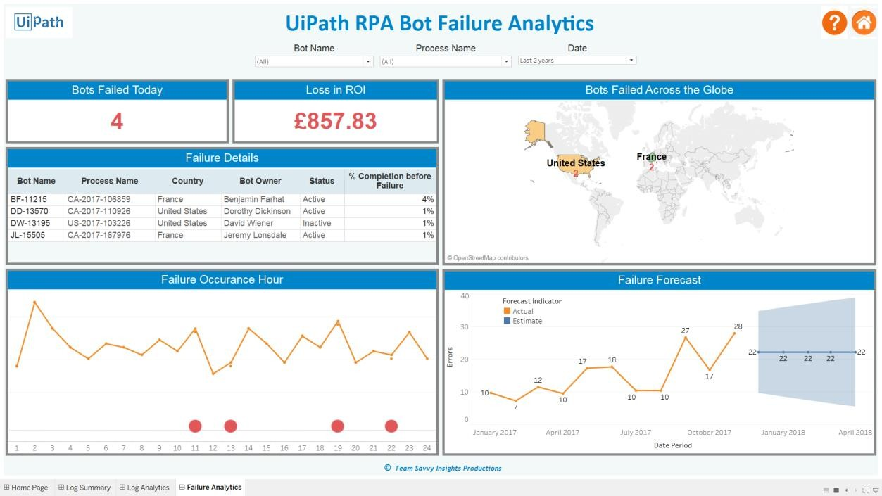

|  |  |  |
| --- | --- | --- |
| **Failure Analytics** | | |
|  | To provide the number of  bots failing on a given day.  ***Allows the users to understand the failure of any Bots on a given day.*** | Metrics-  1. Count of Bot Errors  2. Filter date as Today |
|  | Business users can  customise their ROI calculations for loss when there is a failure.  ***Providing the ROI Loss allows users to have a check on their failed bots and how they affect the revenue stream.*** | ROI loss can be  calculated from the number of bots failed and the cost of the bot for the time period it failed. |

©Team Savvy Insights Page 13 of 15 V1.0

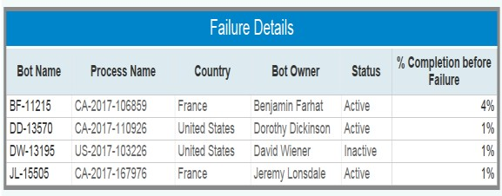

|  |  |  |
| --- | --- | --- |
|  | Detailed table about the  failed bots.  ***Allows users to understand where and when the bot failed.*** | Metrics –  1. Bot Name  2. Process Name  3. Country  4. Bot owner  5. Status  6. % completion |
|  | Global Distribution allows  the user to have a consolidated view of all the failed Bots and their location.  ***Allows users to take a consolidated look on the failed bots they own.*** | Metrics-  1. Count of Failed Bot  2. Location of the Bot |
|  | Hours when the Bots  failed.  ***Allows Bot owners to understand which hour of the day a bot failed. Scope would be to run analytics model to understand and predict the failures.*** | Metrics –  1. Failed bots  2. Time period - Hourly |
|  | To understand how the  errors have occurred in the past, thereby forecasting the error occurrence for  the future over months.  ***The Blue estimate provides a look into how the errors would occur in the future (current data till 2017, the chart forecasts for 2018).*** | Metrics-  1. Count of Bot Errors  2. Time period - Monthly  Forecast calculation in  Tableau |

©Team Savvy Insights Page 14 of 15 V1.0

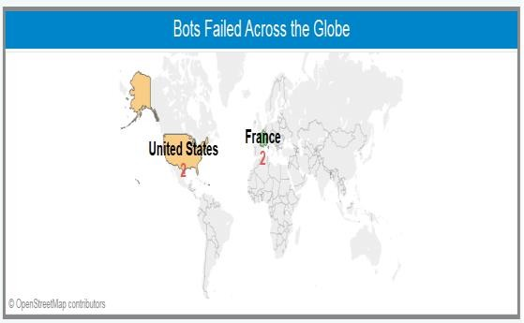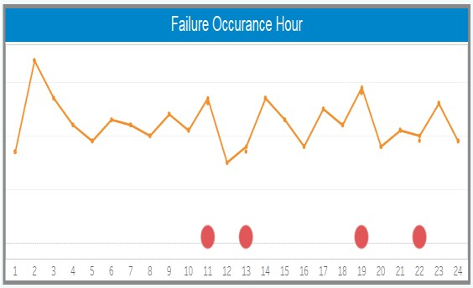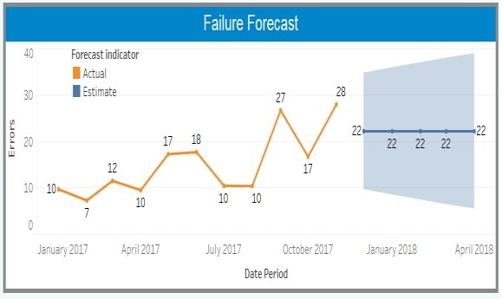

**7. Scope Statement**

7.1 Email Alerts

When a bot fails, the data field which indicates the bot failure would be chosen by tableau to send failure email alerts.

After developing the dashboard in tableau desktop, it would be published to Tableau server. In tableau server, the email alert condition would be applied. Thereby the users of the dashboard would receive the error alert email.

7.2 Failure Prevention

To build analytics model to prevent the failures of Bots in the future based on the metrics identified. Prevention would involve message/email alerts sent to the Bot owner.

7.3 Failure mode Prediction

To build analytics model to predict the failures of Bots. Based on the prediction, the dashboard would forecast the utilization and cost savings incurred to the business.

**8. Assumptions, Risks & Limitations**

8.1 Assumptions

• Data source is consistent and unique(has the exact data fields).

8.2 Risks

• Sample dataset would differ from the Actual. Thus data engineering has to be considered before the dashboard is developed.

8.3 Limitations

• Utilized Tableau Public (which involves data in Public cloud). Investment on

Tableau tool is high.

Alternative: In-house tools could be used to deploy the same use cases.

• Sample Bot log created for the dashboard. Connection to Actual Bot logs could involve changes in the scripts.

©Team Savvy Insights Page 15 of 15 V1.0